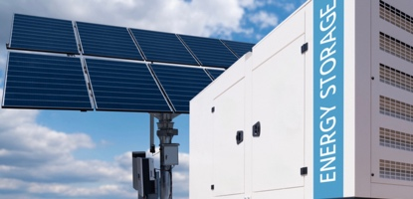 |  | IAEI 2026  Western Section  Meeting |  | 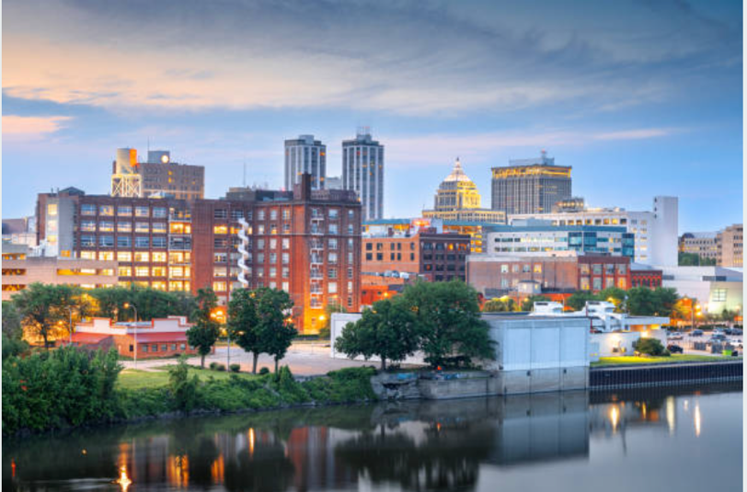
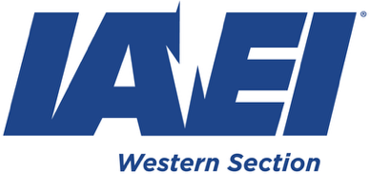
September 13-16, 2026
An Invitation to the 2026 Western Section Meeting in Peoria, Illinois
September 13-16, 2026 |  |  | Venue: Legendary Pere Marquette Marriott  Get ready for an electrifying experience at the 2026 Western Section IAEI, happening in Peoria, Illinois, at the amazing Pere Marquette Marriott Hotel! This legendary hotel, which is celebrating its 100th Anniversary in 2026, has been the grand host to some truly amazing guests, like presidents John F. Kennedy, Ronald Reagan, and Gerald Ford, and legendary entertainers such as Dolly Parton, Elvis Presley, Kenny Rogers, and Sting. With its breathtaking renovations, this majestic hotel promises an unforgettable stay. Peoria is a walkable area with a diverse selection of local eateries, captivating riverfront views, and interesting attractions.
Pere Marquette Marriott
501 Main St. Peoria, IL
Room Rate | 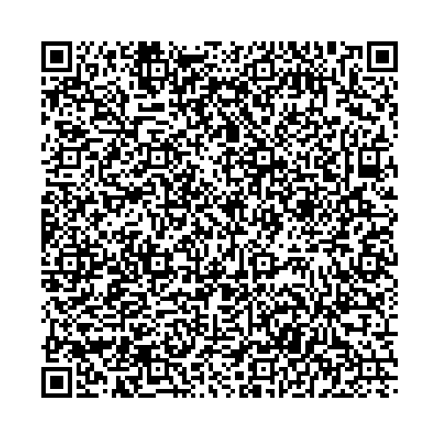
$113.00
Parking $15
Reserve Soon
Meeting Registrations
Members $425.00
Non-Members | 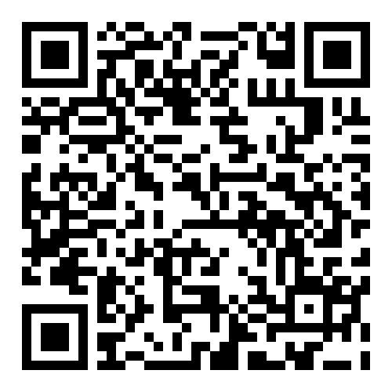
$550.00 |  |  | The Exhibitors will be showcased in the magnificent Cotillion Ballroom, a venue that has welcomed many of these famous personalities. Don’t miss out on this extraordinary event! Exhibitor Fee $1,000  Exhibitor Space Available |  |  |  | 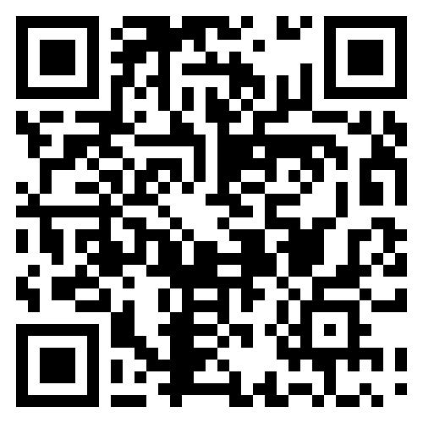
Companion
Full Program $225.00
Companion Reception and
Banquet Only $95.00
 |  |  | Meeting: Educational Program
Program Ads and Sponsorships |  |  | The technical program is the highlight of the Western Section Meeting. Examples include 110.16 Arc Flash Protection, UL 9540A Fire Test Reports for Energy Storage Systems, and EV-PV’s Integration challenges. Completing remote electrical inspections, the New Ask the Inspector program, and the NECA Charlie Trout Code Breakfast.
Program booklet and sponsorship opportunities are available. Special Thanks to our Industry Partners!!
Full-Page $275 | 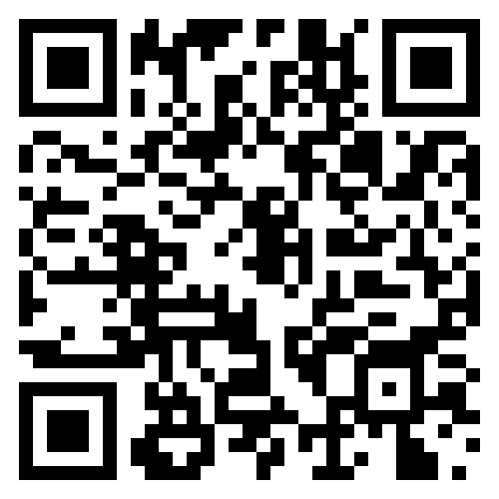 |  | We have assembled an exceptional lineup of presenters including, Alan Manche, Dan Neeser, Brian Baughman, Ryan Jackson, Tom Blevins, Dean Hunter, Don Iverson, Kyle Krueger, and Bill Schaumann. Their unmatched expertise in the Code promises to be an unforgettable event!  Online Meeting Registration
Half-Page $225
Additional Options
Chapter/Division
Discounts
Any questions can be directed to David Williams Dave.IAEI.Western@gmail.com / (517) 719-3186

