Western Section IAEI 121st Annual Meeting
September 14-17, 2025
Holiday Inn
110 2nd Avenue
Kearney, Nebraska 68847

Name_________________________________________________ First Name on Badge___________________
Last Name (print or type) First Name MI

Address________________________________________________Telephone____________________________

City___________________________________________________ State_________ Zip____________________

Email Address: _________________________________________For Registration Confirmation by Email, Check Here 

Representing ___________________________________________Social Security No.____________________
Required for CEUs (Last 4 digits only OK)

Spouse Attending (Name) _________________________________First Name on Badge___________________

REGISTRATION FEE PRE-REGISTRATION LATE REGISTRATION AMOUNT PAID
Must be Received by Sept 1 If Received After Sept 1
Member (Member #_____________) $400 $475 _________
Spouse $200 $225 _________
Non-Member (Includes IAEI membership) $550 $625 _________
Vendor Booth Assistant $150 $150 _________
Banquet Only $75 $75 _________ Total _________
Credit Card Fees (if used) are not included in Registration Fees

Please indicate if you plan to attend the following events included with your full registration:

Sunday evening Welcoming Reception YES  NO 

Tuesday evening Banquet YES  NO 
Spouse Trip on Monday YES  NO 
Spouse Trip on Tuesday YES  NO 

Information on meeting can be found at: http://IAEI-Western.org

Make checks payable to: Western Section IAEI

Mail meeting registration to: Tom Moore 3462 Brunk Rd Akron, Ohio 44312

Phone: (330) 289-7932 Email: tmoore1767@gmail.com
- 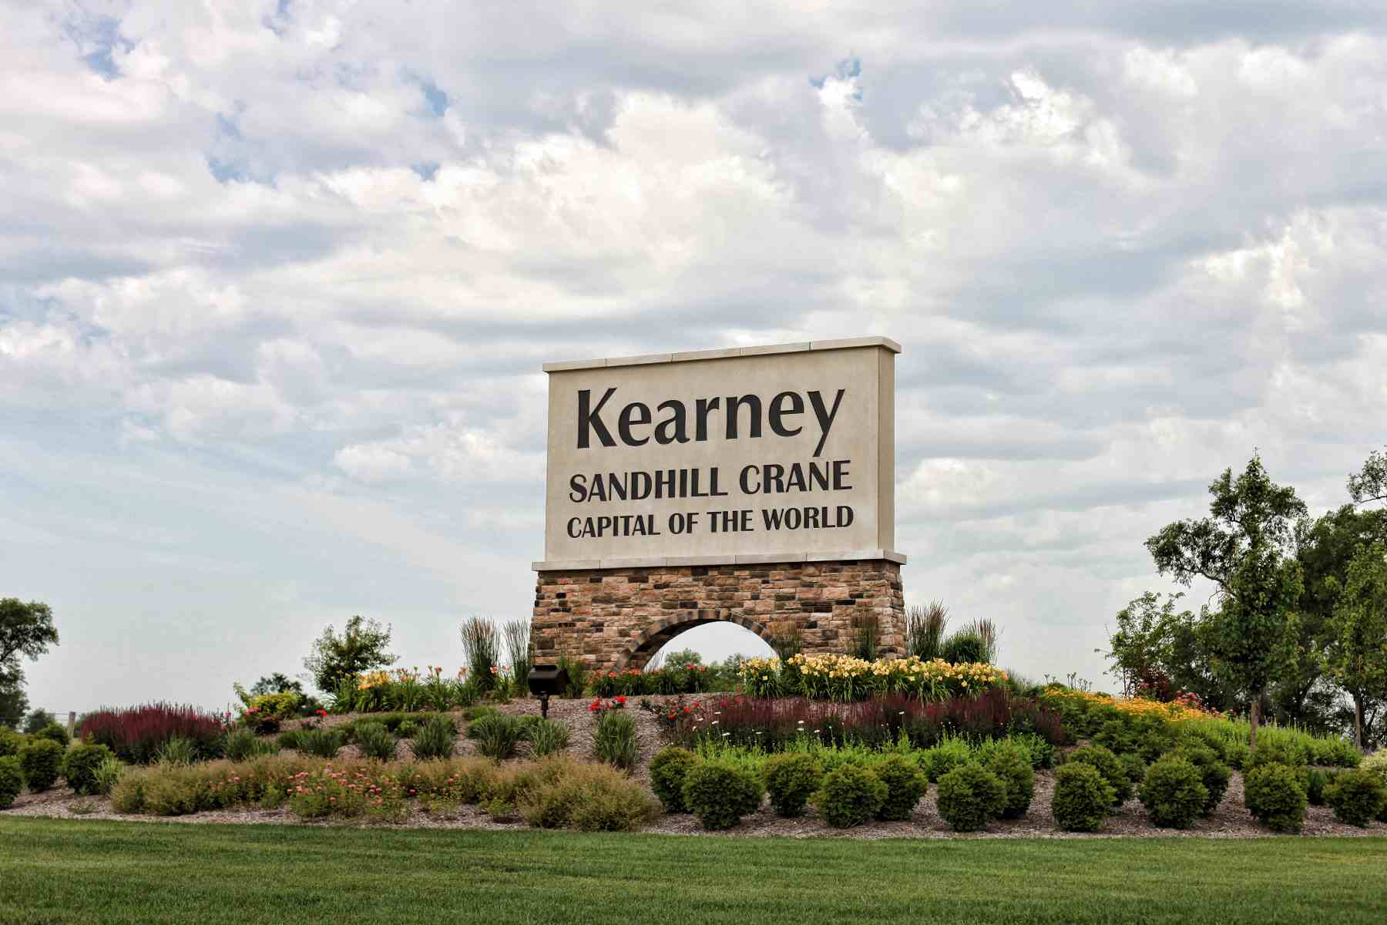

HOTEL RESERVATION
The Western Section has a block of rooms at:
The Holiday Inn Center
110 2nd Ave
Kearney, NE 68847
Reservation 308-237-5971
Room Rate: Single $119.95 Plus Tax

Guests must call Hotel direct (308) 237-5971

.

